**Final Report**

**Capstone Project - Final  
The Battle of Neighborhoods  
IBM Applied Data Science Project – Week 1 & 2**

**The Business Problem:**

**Vending machines stations carrying PPE products**

**Contents:**

* **1- Introduction**
* **2- Data**
* **3- Methodology**
* **4- Results**
* **5- Discussion**
* **6- Conclusion**

1. **Introduction**

As the year 2020 is a whole different year due to the COVID-19 pandemics, PPE is thriving, and the market is very financially rewarding.

Vending machines carrying PPE products (Personal Protective Equipment) like masks, gloves and sanitizers are highly demanded as people are always in need of PPE when they want to visit a venue or doing an activity however it takes a lot of time to locate and find a store to buy, while vending machines if well placed in the city can deliver them PPE products conveniently.

**Audience AKA Stakeholders!**

Audience for this project would be vending machine provider companies and PPE producers so they could plan to deliver vending machines carrying PPE products to the city of Vancouver in British Columbia.

The goal of this project is to find busy and populated areas with lots of venues around by using Foursquare API and Google location data API to guarantee massive sales and a profitable business plan in terms of selling PPE products through vending machines.

**Customers:**

The potential customers of these products will be the people visiting a venue which in most cases they need to wear a mask, use sanitizer gel or preferably using disposable gloves which will be carried by the vending machines.

We are currently in phase 3 in response to COVID-19 which means People can take part in smart, safe and respectful activities within British Columbia.

Taking precautions such as wearing masks, using sanitizers and disposable gloves will highly decrease the risk of infections by Coronavirus.

1. **Data**

In this project I will be working on the location data of Vancouver city targeting best neighborhoods and pin points in the city which are the best places to set up and install vending machines stations.

The data will be used for this project coming from different sources like getting the neighborhoods and postal codes of Vancouver from Wikipedia and using Google location data API for Latitude/Longitude of neighborhoods, then by applying Foursquare API, I will get details about the venues available in different part of the city. The main idea is to find the best locations and pinpoints by clustering Vancouver city and find 10-20 start-up points for setting up PPE vending machines stations.

1. **Methodology**

Visualizing Vancouver's map with neighborhoods superimposed on it.

Utilizing Foursquare API in order to explore and segment Vancouver's neighborhoods to find our pinpoints meaning the best spots to set up the PPE vending machines.

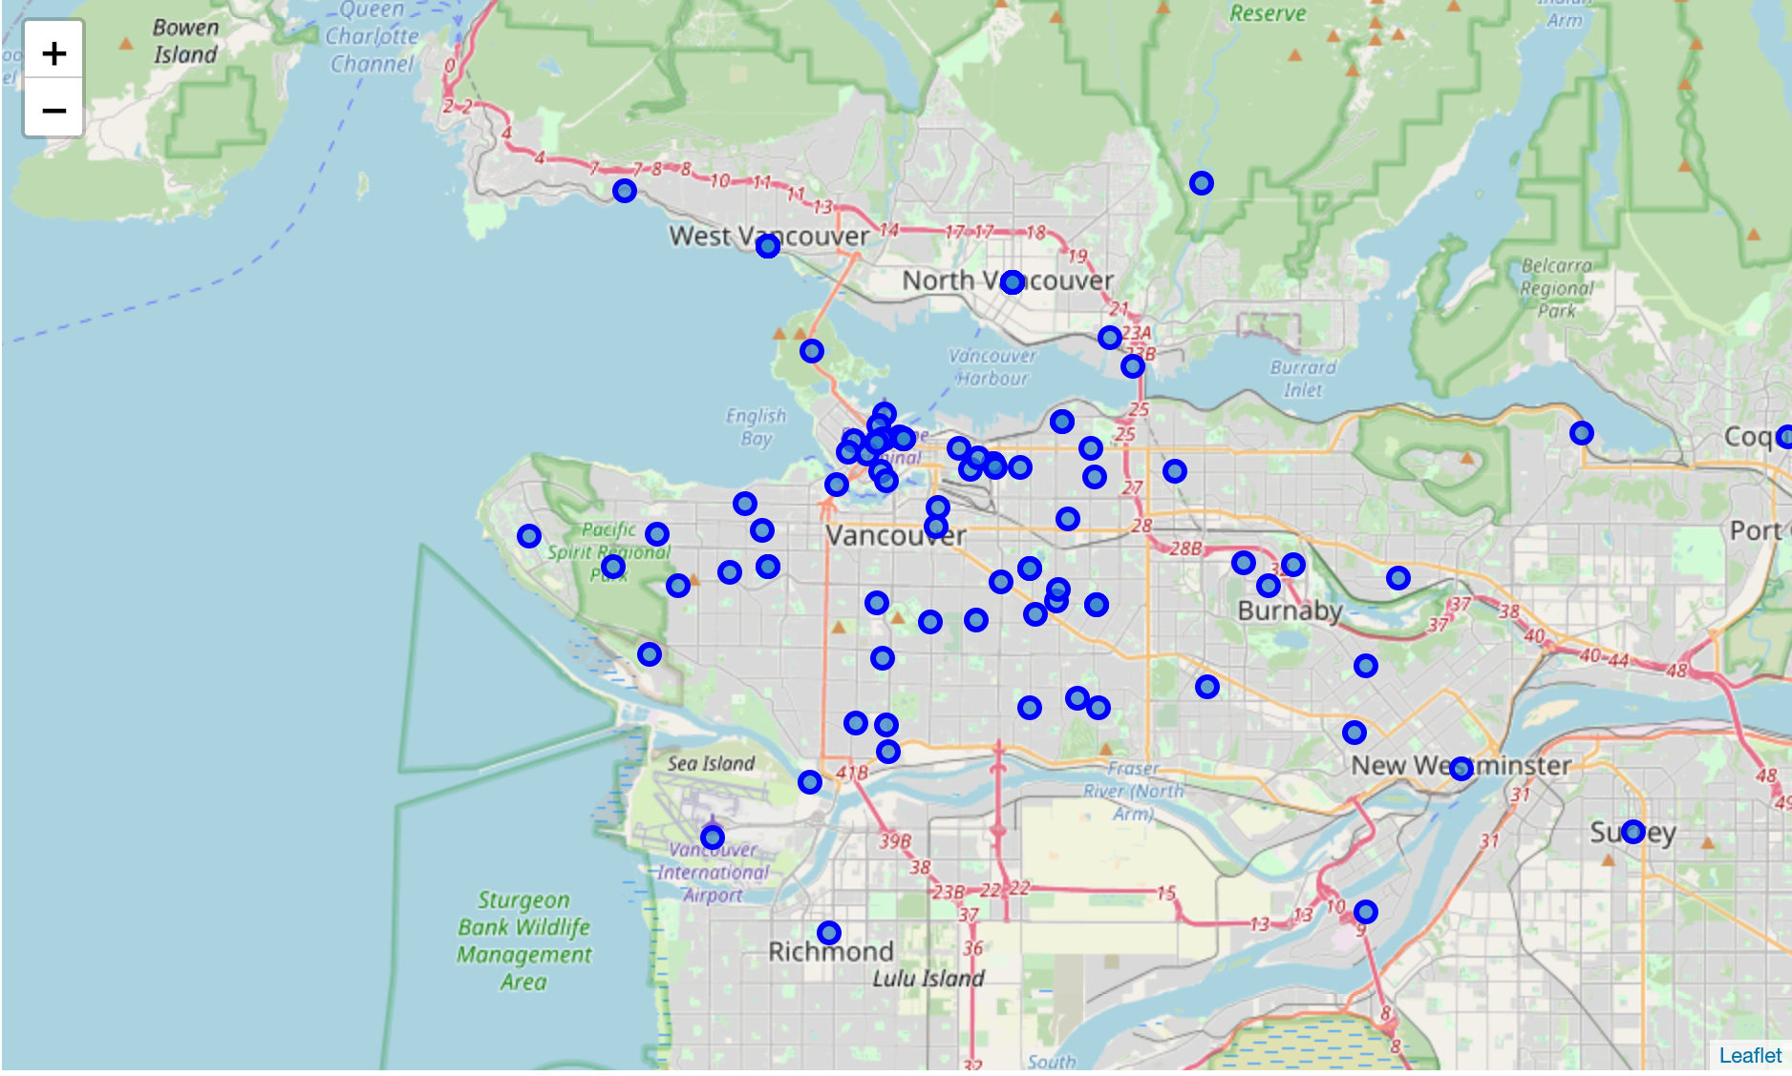

1. **Results**

K-means clustering:

Clustering neighborhoods to find the pinpoints for vending machines locations.

Plotting and visualizing the clusters to find our pinpoints.

Forming 10 clusters as a result of 2 clusters which having the most venues.

**K-Means clustering results:**

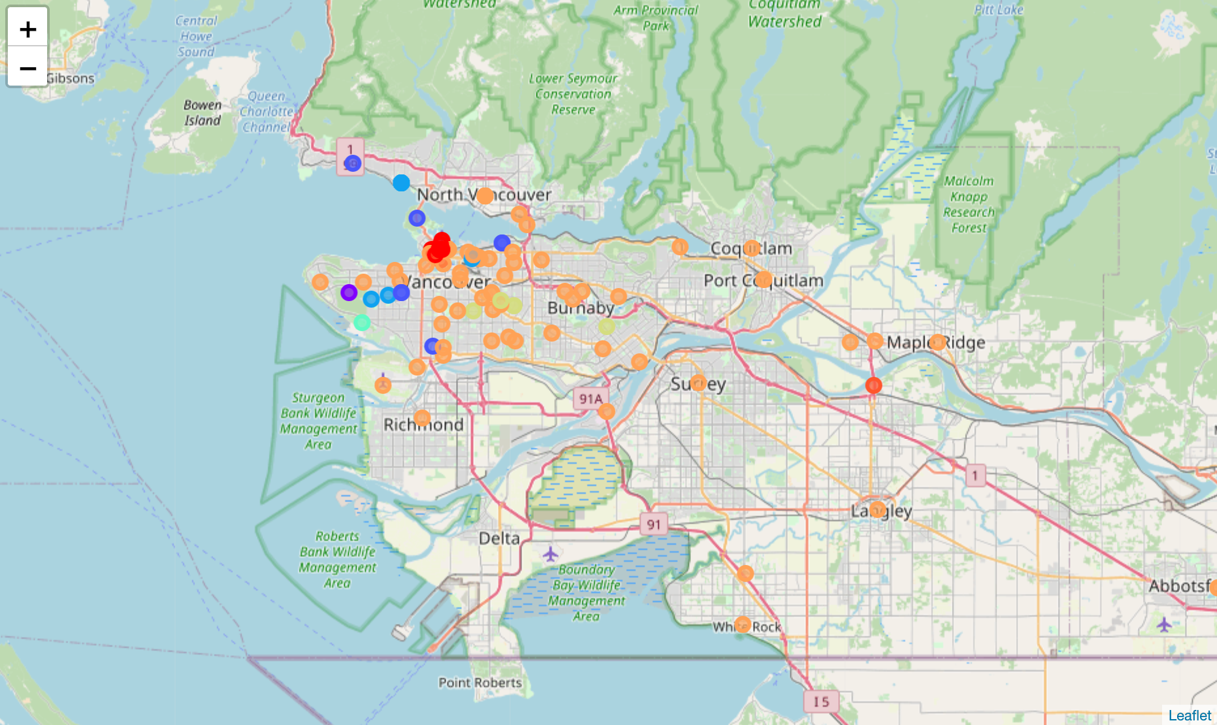

1. **Discussion**

The results show that clusters number 9 and 1 respectively have the most venues which the best spots for investment in the first phase of are setting up the PPE vending machine stations.

Clusters 4, 3 and 8 also can be considerable for second phase of the business expansion.

Based on the amount of venues in cluster 9 and 1, it guarantees there are huge amount of people in those areas all the time during the day and a great opportunity to sell PPE products through the vending machines.

Although vending machines are fully automated, still the supplier needs to replenish the machines with new products and also must set up an efficient monitoring system to notify them when machines should be refilled.

1. **Conclusion**

Implementation of PPE vending machines are very demanding based on the market's need. In current situation that staying safe and healthy matter to all of us, the business of setting up PPE vending machines is highly profitable.

The work in this project is valuable for every PPE supplier company which desire to help people out in this tough situation and also make tremendous profit and get a high payback for their investment.

Created by J.E